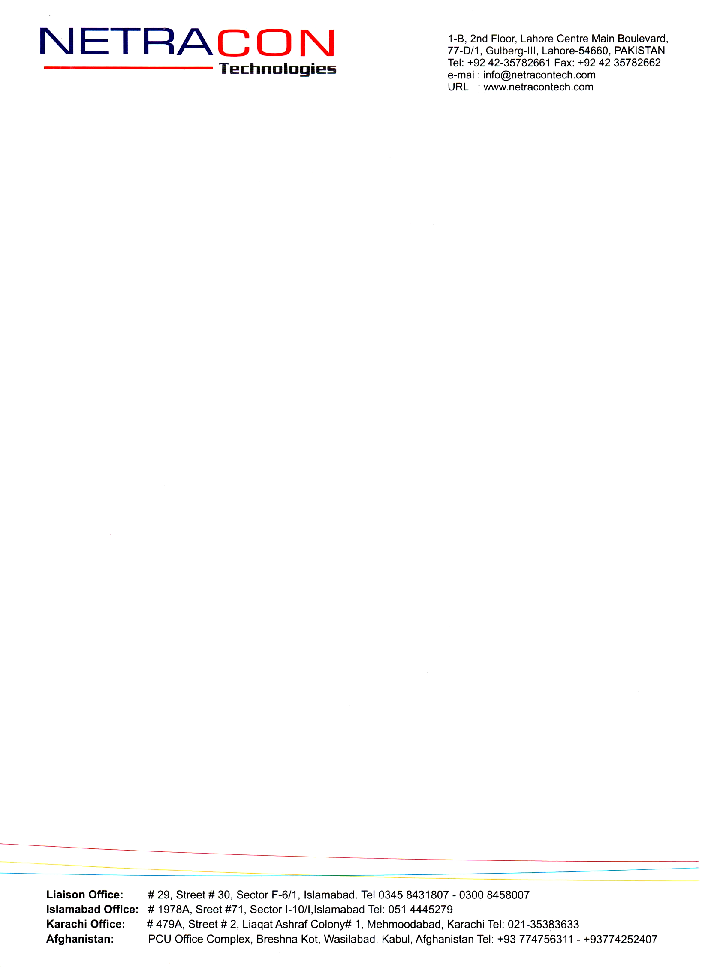

Date: <To2>

**To Whom It May Concern**

It is certified that Mr. <Name> S/O <fname> has been working as <Designation> in site office Kabul for the construction of Jadeed Feed Mills Khanewal w.e.f. <From2> to <To2>.

He takes keen interest in his job. He is obedient, hard worker and bears good moral character. He may success in life.

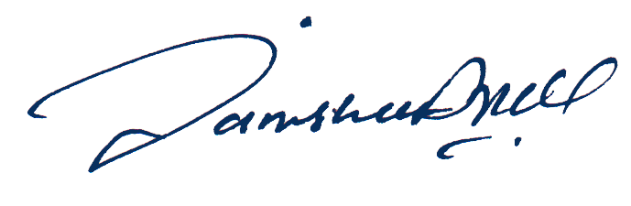

**Engineer Ihsan-ul-Haq Butt**

Project Manager

NETRACON Technologies

Lahore